2014 Machine Learning - Homework 1

103522064 王泓翔

1. Please search for the definition of “Convolution”, in the textbook of Engineering Mathematics, or online. Please read it and then use your own word to describe the basic meaning of “convolution”. Please define it with math equation. Please give an example of convolution by first drawing two signals in time domain. Then draw another figure to illustrate what we should do to get the result of convolution.

**Ans: “**Convolution” is a mathematical operation on two function. We can see below formula.

 

Two function f and g is doing convolution, it means that f production g with inverse. The picture below show clearer. It likes Cross-correlation but function g doesn’t reverse.

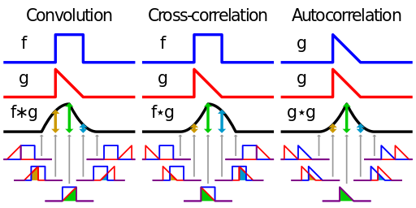

1. Please search for the definition of “Fourier Transform”, in the textbook of Engineering Mathematics, or online. Please read it and then use your own word to describe the basic meaning of “Fourier Transform”. Please define it with math equation.

**Ans:** Fourier Transform assume that every signal can be present with trigonometric in different combination and it becomes easier to be understudied by human. So we can use Fourier Transform in many domain such as music, picture, and electronic signal etc.

|  |  |  |  |
| --- | --- | --- | --- |
| FFT: |  | Inverse: |  |

1. Please describe how to compute “convolution”of two signals by using “Fourier Transform”. Why do we want to use such method? What advantage can we get?

**Ans:** After 1 and 2 questions, we know that FFT can translate image signal into other domain which is easy to do some calculation. If we don’t use FFT, we have to do inner product each by each elements and it cost a lot, and waste time. The advantage is saving time.

1. Please search for the definition of “cross-correlation”in signal processing field, in the textbook of Engineering Mathematics, or online. Please read it and then use your own word to describe the basic meaning of “cross-correlation”. Please define it with math equation.

**Ans:** Like question 1’s answer, Cross-correlation is very like Convolution. Both operations are doing product, but Cross-correlation doesn’t reverse the function g. The formula is below.



1. Please describe how to compute “cross-correlation”of two signals by using “Fourier Transform”. Why do we want to use such method? What advantage can we get?

**Ans:** Our goal is using “Cross-correlation” to recognize some part of image. After 1 and 2 questions, we know that FFT can translate image signal into other domain which is easy to do some calculation. If we don’t use FFT, we have to do inner product each by each elements and it cost a lot, and waste time. The advantage is saving time.

1. (a) Elapsed time is 17.805448 seconds.

(b) surf ( new ( 1:5:end, 1:5:end ) ); colormap hsv; colorbar;

If we use every domain to draw plot, it will become dark because it’s too crowded to show the color.

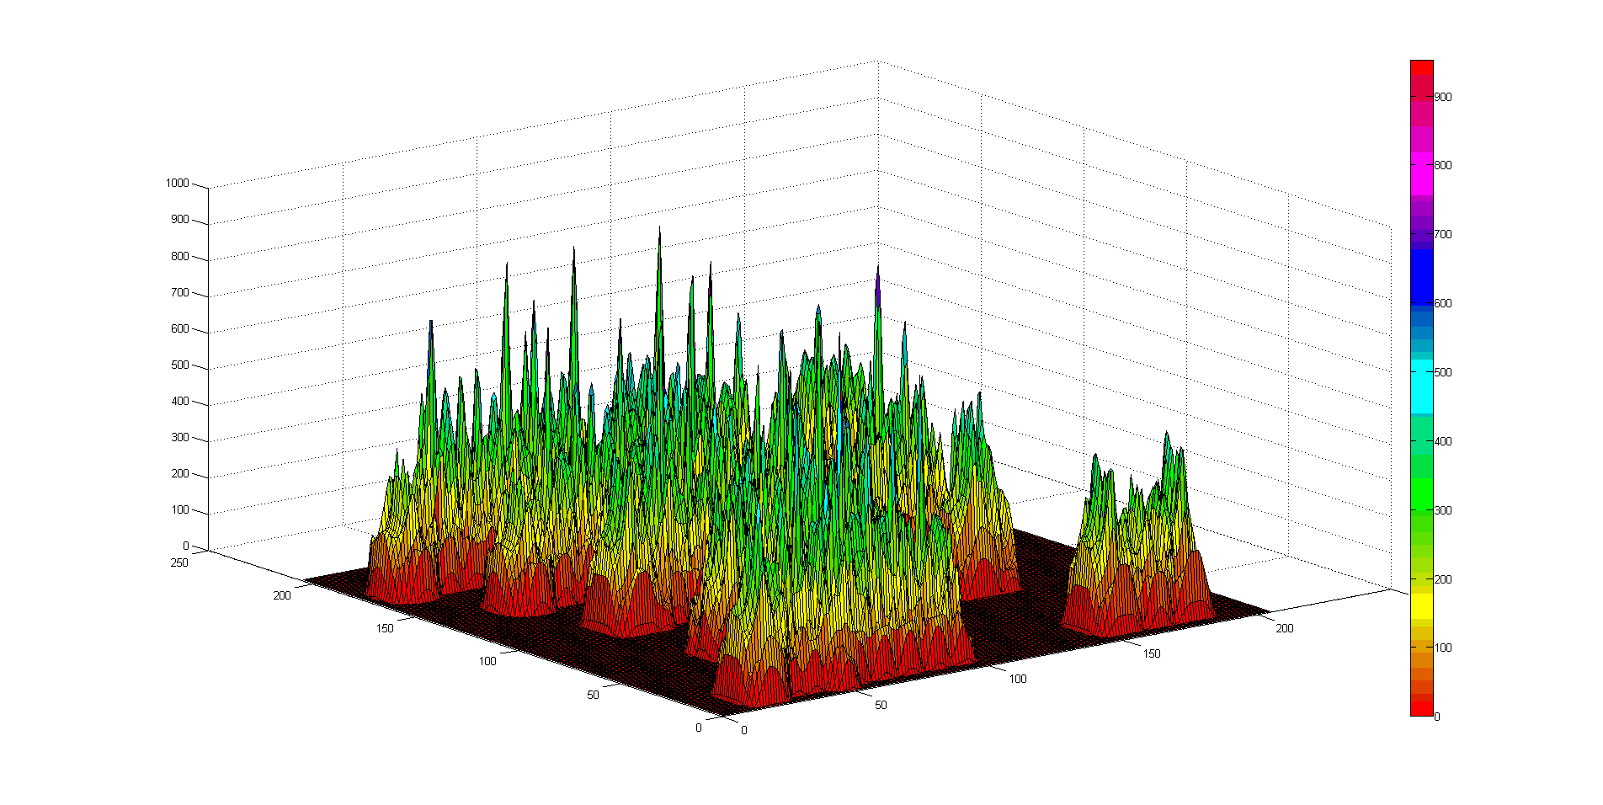

(c) Threshold value = 1000

(d) Elapsed time is 1.088138 seconds. There is a different in taking time. Inner product took 15 seconds to finish but FFT only took 1 second. That make me realize the powerful of the FFT. The same is that they both can recognize the letter.

(e) Threshold value = 900

|  |  |  |
| --- | --- | --- |
|  |  |  |
| (c) | (d) | (e) |